Code 1.1.2 } Write a Python program to calculate the area of a rectangle given its length and width.

Algorithm :
Step 1 : start
Step 2 : input of length and width
Step 3 : calculating area = length * width
Step 4 : stop

Code :
Length = int(input())
width= int(input())
area = length * width
print(f”{area:.2f}”)

Flowchart :
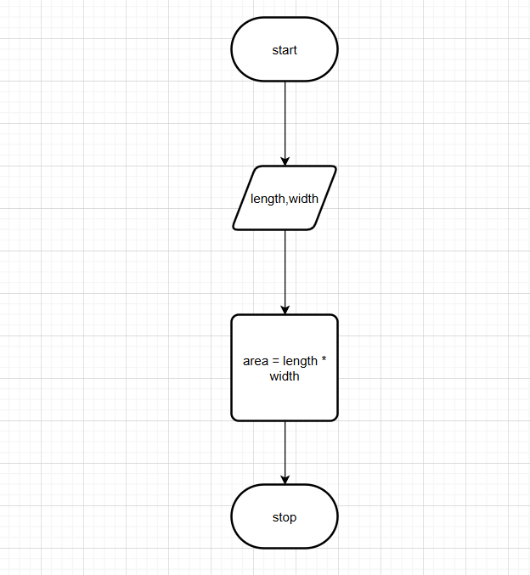

Codetantra :
